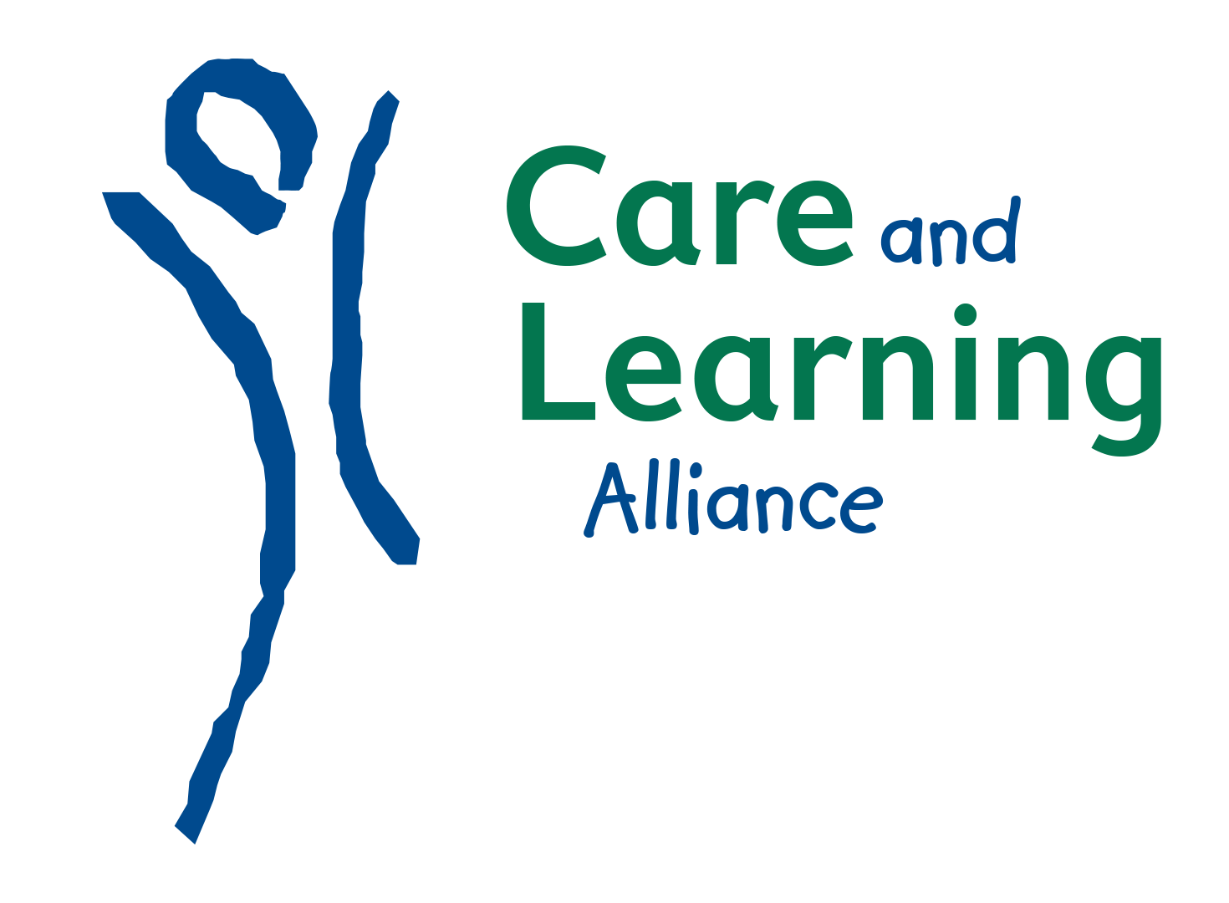

PERSONAL SPECIFICATION

Post: Family Play Practitioner

Attributes | Essential/Desirable | Essential | Desirable
Experience | - Extensive previous experience of working with children and young people and families.  - Knowledge and experience of implementing national childcare standards and legislation, Curriculum for Excellence, GIRFEC and other national policy and guidance.  - Evidence of strong interpersonal relationships with co-professionals.  - Providing, and signposting to, advice and support for families | 
Education and Qualifications | - Good general level of education.  - Associated qualification to post at SCQF Level 7 or above e.g. SVQ 3 Social Services (Children & Young People); HNC Childhood Practice, SVQ Playwork etc,  - Be able to demonstrate prior learning and ongoing development in children and young people related training  - It is CALA policy that all staff recruited will undertake relevant training and actively participate in learning opportunities.
Skills / Ability specific to the post | - Excellent oral and written communication skills.  - Excellent time management and ability to manage own workload  - Respect professional boundaries  - Passion and enthusiasm to give children the best start and support others to do so.  - Ability to provide strong and effective leadership and the capacity to motivate and develop teams and individuals.  - Ability to respect confidentiality.  - Ability to work on own initiative and as part of a team.  - Strong IT skills in a range of MSO packages and email.  - Ability to respond calmly and efficiently in an emergency.  - Willingness to adapt to any new challenges, acknowledging the importance of continually improving professional practice.  - Clean driving license
Interpersonal & Social Skills | - Ability to relate easily to professionals, adults and children.  - Outgoing personality.  - Drive for personal learning and encourage this in others.  - Understand and value fairness, diversity, dignity, social  - Inclusion, equality and anti-discriminatory practice  - Non-judgmental, inclusive and welcoming approach  - A commitment to reflection, self-evaluation and self-development as a means of enhancing working practice and broadening expertise
Specific to post and essential | - Full, clean driving license

