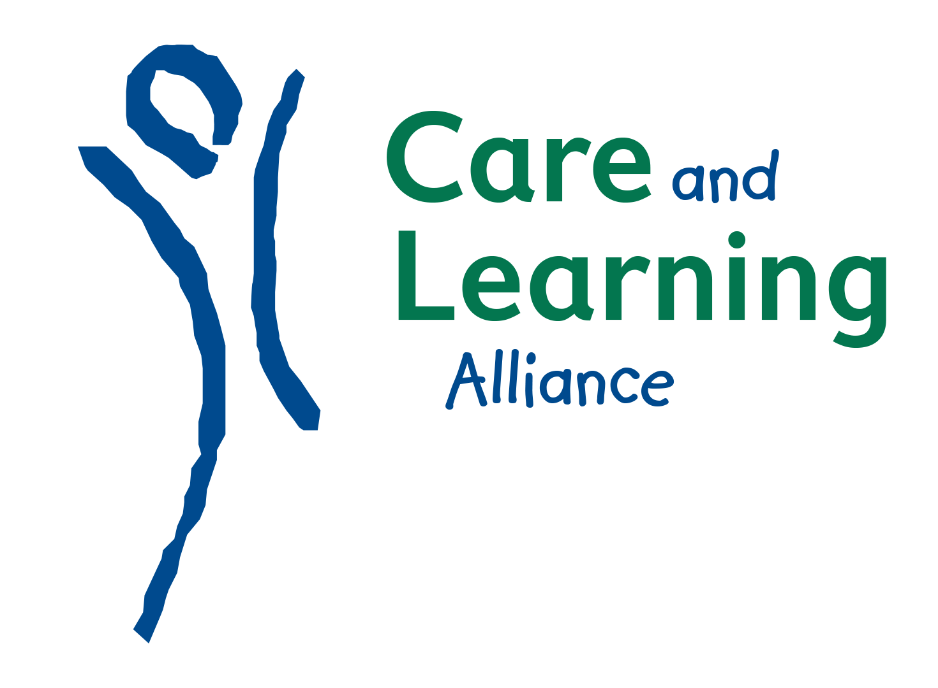

Positive Childhoods Empowered Parents Dynamic Communities

Job Description Family Play Practitioner

The Family Play Practitioner (FPP) will be a dynamic and enthusiastic practitioner, passionate about the importance of play for young children and families. An ability to work flexibly, using your own initiative in planning and delivering the work is a key requirement.
The post holder is line managed by the Head of Quality, Learning and Workforce Development. The post is home based and will involve some extensive daily travel from the Inverness area. Most hours will be worked flexibly Monday – Friday with some occasional weekend work as required. The Family Play Practitioner (FPP) is employed by and will be accountable to the Directors of Care and Learning Alliance.

Professional Values and Personal Commitment
The FPP will demonstrate enthusiasm and sensitivity and act as an advocate for the benefits of play in supporting all aspects of children’s learning and development. They will set high standards for their work and encourage others to aim for high quality in all aspects of their work with children and families and other professionals to secure positive outcomes.
Main duties of post
The FPP will:
- Work effectively as a part of a team delivering on various play-based projects to ensure high quality play and learning opportunities for children that meet the outcomes set out by the funders.
- Develop strong effective relationships with staff, parents and children within each of the projects service users.
- Plan and support the delivery of high-quality play sessions face to face engaging children, young people and families.
- Plan, organise and deliver School/ELC/Parent/Toddlers/Community workshops to promote the understanding of how the inclusion of access to high quality play enriches the lives of children and links with improved attainment.
- Maintain clear records relating to sessions delivered and other support work including reporting on programme outcomes and impact.
- Work flexibly in the variety of Toddler/ELC/School/SAC and community settings, raising awareness, identifying and reducing barriers to ensure children and young people have access to fun, open ended and inclusive play.
- Work closely with colleagues in CALA and partners to ensure the aims/outcomes of all projects involved are fully met.
- Communicate timeously and as agreed with Line Manager.
- Perform any other duty reasonably falling within the scope of the post as determined by the Line Manager.

Professional Knowledge and Understanding
The FPP will:
- Have a secure understanding of how children learn and develop and how to support each child’s individual needs, interests and character.
- Have a secure understanding of Play Principles and values.
- Be aware of the previous and current Play Research Evidence and Evaluation Reports to support informed delivery of play across CALA services.
- Have a working knowledge of policies and frameworks at national, local and organisational level including Curriculum for Excellence, GIRFEC, Realising the Ambitions, Play@home, and other relevant frameworks and initiatives.
Professional Skills and Abilities
The FPP will:
- Have excellent communication (oral, written, ICT, presentational).
- Have effective organisational, time management and prioritisation skills.
- Ensure a highly professional and positive attitude is always presented.
- Value and respect the contribution of others.
- Value and promote fairness, diversity, social inclusion and anti-discriminatory practice.

Professional Learning and Development
The FPP will:
- Develop and value themselves and others by taking responsibility for their professional learning and development.
- Positively contribute to the internal CALA support, supervision and appraisal processes to aid on-going development.
- Seek to achieve continuous improvement and leadership skills through on-going reflection and evaluation of the service provided.
- Engage in professional reflection.

This remit will be reviewed at end of fixed term contract subject to project funding being continued.

Care and Learning Alliance is an Equal Opportunities Employer

