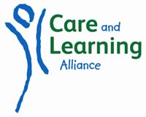

CARE AND LEARNING ALLIANCE

CLEANER - Personal Specification

Attributes | Criteria | Essential  in Post | Desirable  in Post
Experience | Experience of undertaking a range of cleaning duties | X
Knowledge/Skills/ Abilities | Ability to work on own initiative and to deal with any unexpected problems that may arise | X
 | Ability to work in an organised and methodical manner  Ability to complete cleaning tasks to desired standards and to work to time constraints  Some knowledge of Health and Safety procedures and precautions as they relate to the operation of cleaning equipment and the dilution of cleaning materials | X  X  X | X
 | Must be willing to maintain confidentiality | X
 | Must be willing to clean any area of the school as requested by the Centre Manager | X
 | Reliable and consistent | X
 | Responsible for the security of building as a designated key holder | X

