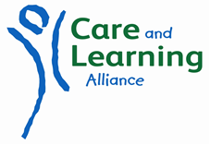



*Invite you to an*

**Evening Workshop for Childminders**

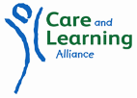

This training is **Free**

**Book online:** [**http://careandlearningalliance.co.uk/training/childminder-workshop-wick.html**](http://careandlearningalliance.co.uk/training/childminder-workshop-wick.html)

**Or telephone 01463 703033**

30th November from 6.30pm to 8pm

Pultney Town People’s Project

Wick

*Through a blend of interactive tasks, discussion and video clips the workshop will provide opportunity for childminders to:*

* To raise awareness of the Care Inspectorate’s newly issued resource ‘Your childminding journey: a learning and development resource’
* Gain an understanding of the wider work of Care and Learning Alliance (CALA) as an organisation.
* Develop awareness of the many benefits of CALA membership for Childminders.

© Care and Learning Alliance 2016 – Scottish Charity No: SCO09292