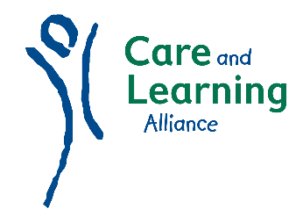

PLIP Course Outline (ELC)
- Course introduction, expectations, communication and team building. Introduction to child development and health 0 - 16 years, including when and where children learn, defining and meeting children’s changing needs. Gain an insight to the key areas of Curriculum for Excellence.

- Explore the value of active learning, developmental milestones, the influence of theorists on cognitive development, the adult role in supporting learning and related current national guidance.

- Consider principal factors affecting children’s development and how these may have a positive or negative impact. Explore the importance of relationships and quality interactions on early brain development. National strategies supporting health and well-being.

- Gain understanding of the value of play, types and stages of play development and explore some play theories. Explore adult interaction which supports high quality play and learning.

- Consider environments and experiences in ELC including indoor and outdoor learning environment, layout, resources, and the role of the adult in supporting child led learning and the benefits of facilitating reasonable risk in play.

- Our Workshops provide fun play and learning, will help to inspire you and put theory into practice! These include:

Paint
Dough & Clay
Junk Modelling, Collage & Woodwork
Music & Movement
Physical & Energetic Play
Books & Storytelling
Drama & Role Play
Cookery
Sand, Water & Alternatives
Care and learning alliance dochfour drive, inverness iv3 5eb
tel: 01463 703033.
email: inverness@Calachildcare.co.uk
©Care and Learning Alliance 2017

