Rothiemay and District Playgroup Eco-Schools Blog
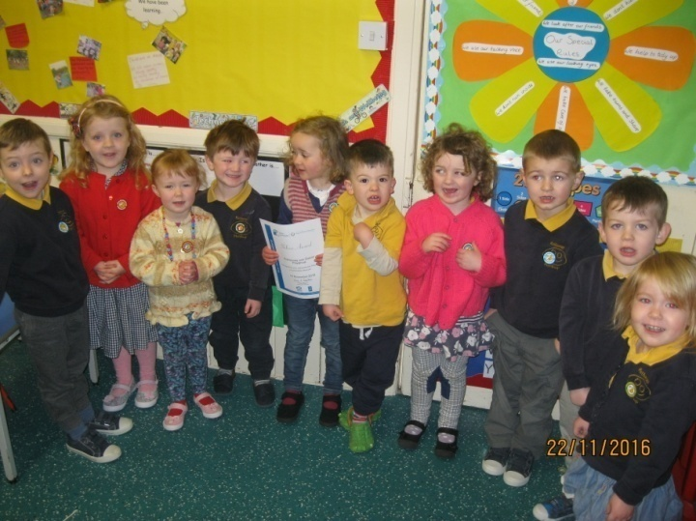
We have been participating in eco-schools for a couple of years now and are delighted to say that after receiving our Bronze Award we have now received our silver award in November 2016.

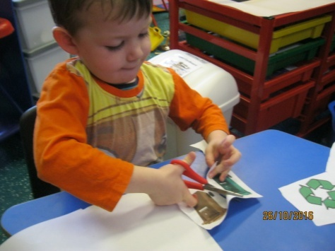
Here are some of the things we’ve been doing…
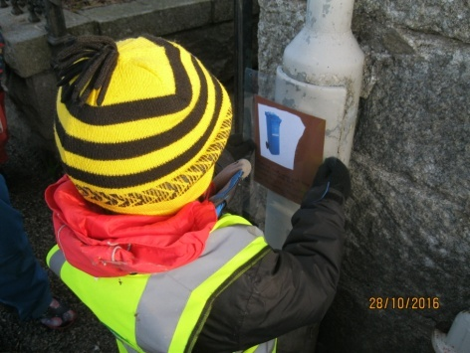
We made posters to remind people of the importance of recycling and putting their litter in the bin and stuck them up around our village.
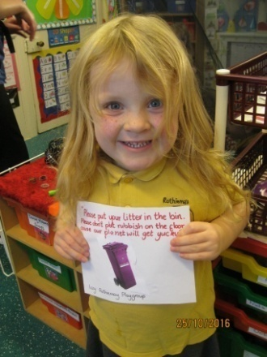
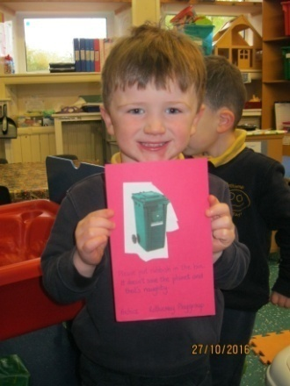

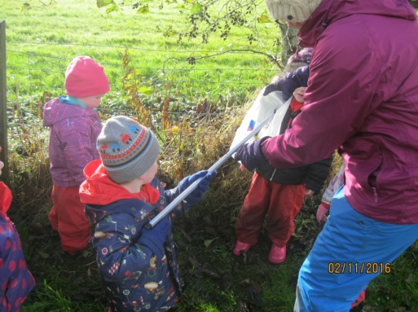

We have litter monitors in place where each day a small group of children are in charge of checking our outdoor area for any litter and if they find some they use a grabber to pick it up and put it in the bin.
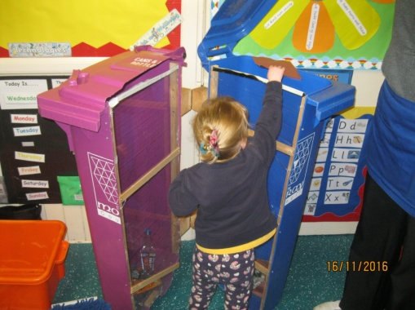
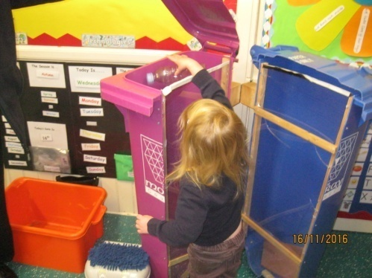
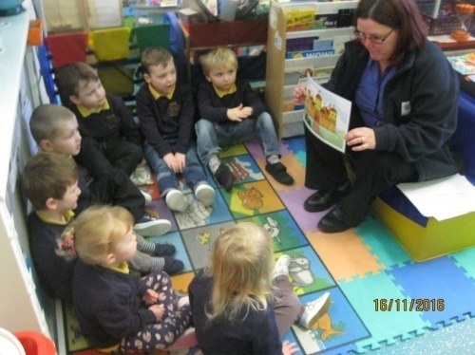
We had a visit from some people from Moray Council who gave us a talk all about the importance of recycling and we helped them sort some rubbish they brought with them into different types of bins.
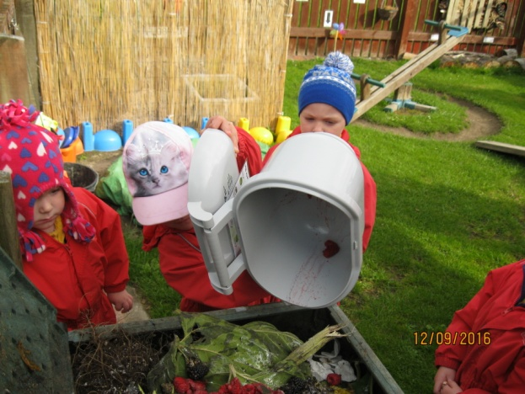
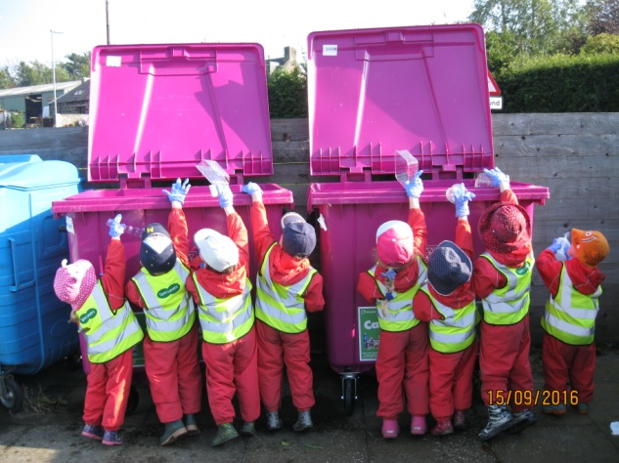
We have our own compost bin in the garden and take regular walks up to the recycling centre in the village with our milk bottles and yoghurt pots.

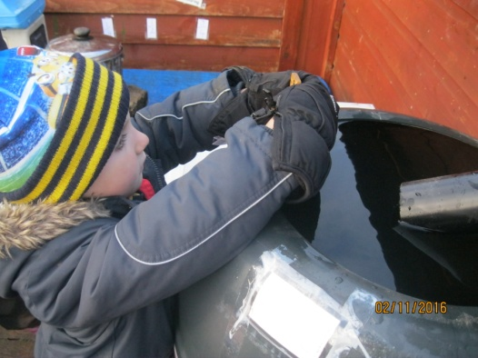
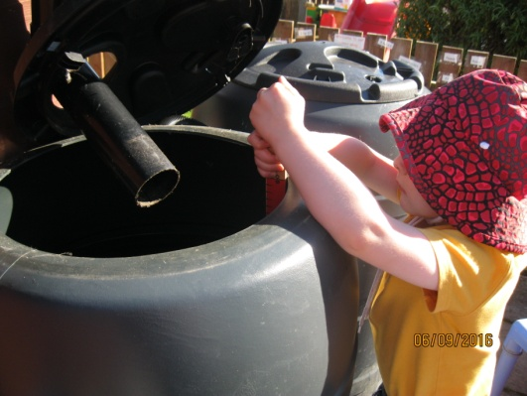
We have installed some water butts in our garden that collect rain water which we measure and then use to water our plants and vegetables.

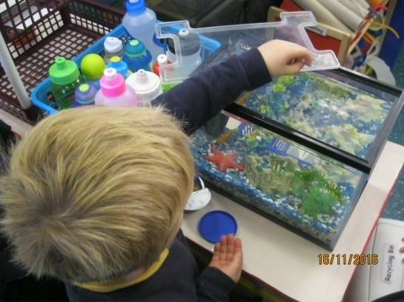
We have a pet fish called ‘Honey’ who the children help to look after. Each day our special helpers feed Honey a tiny bit of food and when the water in the tank needs changed the children will help with this too.

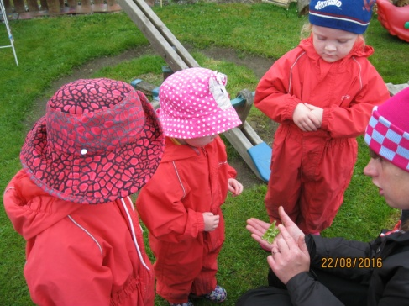
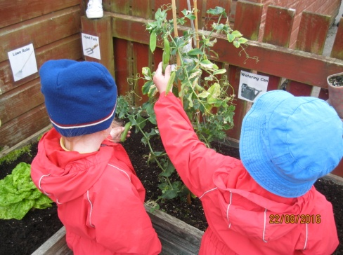
We have an area in our garden where we grow our own vegetables and when they’re ready we try them as part of our snack.

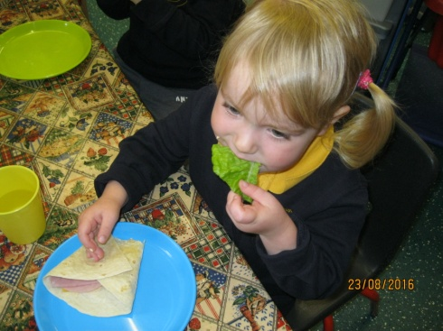
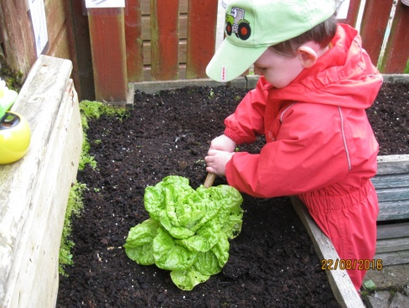

During harvest time we made a food basket and donated it to our local food-bank. The children chose items from our local shop that they wanted to donate and helped to decorate the box before we visited the food-bank to donate the food.
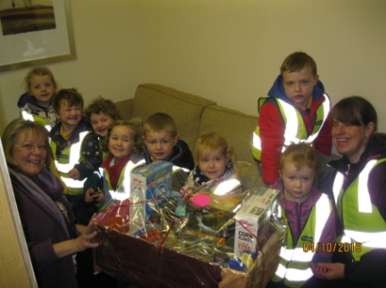
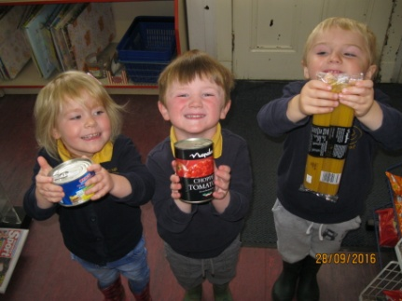
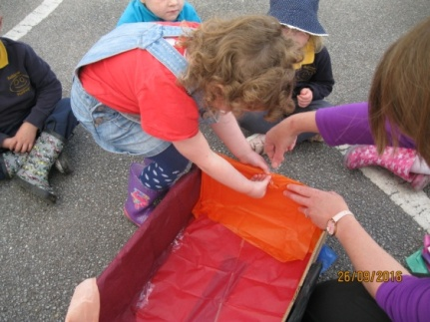
We are all really proud of our silver award and the children have really taken on board the idea of recycling and looking after our planet. We hope to continue this and work towards our green flag award in the future.
Laura Pirie and Rosie Martin, Rothiemay and District Playgroup

