Education Scotland – National Improvement Hub
As many of you will be aware, Education Scotland have recently launched the National Improvement Hub to support continuous improvement in our work with children and families. If you haven’t had a look yet, it’s definitely worth clicking on https://education.gov.scot/improvement/About-NIH . You can view a range of interactive material including guidance and practice example videos and download transcripts and power point presentations to use to support self-evaluation for improvement in your setting. New items are added frequently. We were particularly interested in the report “The Twoness of Twos’ by Jane O’Sullivan and Sue Chambers of the London Early Years Foundation which we found especially pertinent as more two year olds become eligible for funded ELC in Scotland and we strive to improve quality to support positive outcomes. The cover quote by Jerry Seinfeld “A two year old is kind of like having a blender, but you don’t have a top for it” will no doubt strike an only too familiar cord with those of us who have the privilege of knowing and/or working with these little treasures!
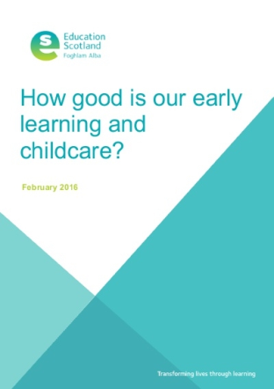
You can also view or download the new framework for self-evaluation How Good Is Our Early Learning and Childcare (HGIOLC) which has been designed to help us ‘take a fresh look at the developing needs and reflect the changes and increased provision of today’s ELC sector’ (source HGIOELC 2016). The framework takes account of childminders, private, voluntary and local authority settings therefore is for all practitioners working with children from birth to starting school. The framework will be used by Education Scotland for ELC inspections from this month onwards.
It is important that we begin to familiarise ourselves with the 15 Quality Indicators within HGIOELC. This will support us to evaluate our strengths, identify areas for development and help us to plan improvement. HGIOELC encourages as to look ‘inwards, outwards and forwards’ – the National Improvement Hub certainly provides us with useful tools to help us do so.

