GOLSPIE ELCC
VISIT TO SEAFORTH HOUSE
MAY 2016

The children at Golspie ELCC have been very lucky this year and have built up a good relationship with the residents at Seaforth House (the local Elderly Care Home). The children have visited the residents on a number of occasions at Seaforth House and invited some of the residents into Golspie ELCC to see the activities that the children like to do.
When some of the residents came into the centre to help the children plant sunflower seeds, we all thought it would be fun to have a little competition to see whose seeds would grow the biggest by the end of May, and the winning centre would get a prize from the losing centre.
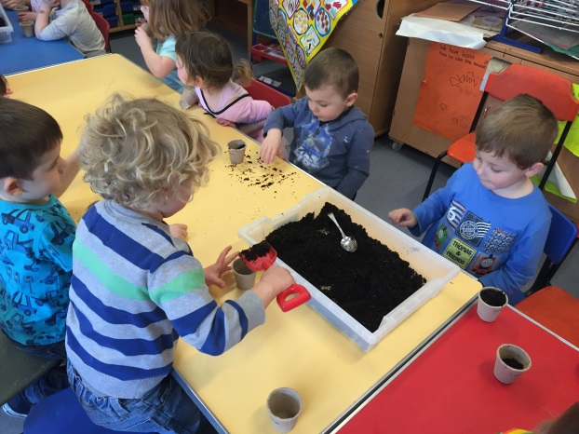

The children shared the planted seeds out between Seaforth House and Golspie ELCC, Julie delivered them to Tracey at Seaforth House later the same day.
When we came into Golspie ELCC each morning we made sure that our seeds had been watered and were put by the window before we went home. As we had learnt that the seeds need the sun and water to help them grow.

We were really excited when we saw that our seeds had begun to grow
“Look they are growing”.
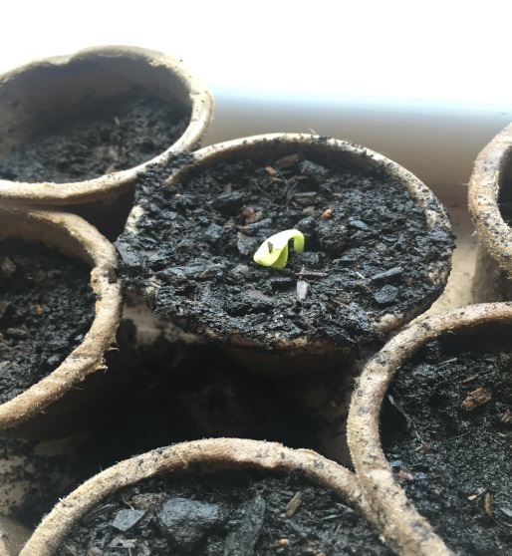
On the 24th May we went to see how well the seeds at Seaforth House had grown and to see who had won.
Before we left we made a `Thank You` card and brought a box of chocolates as a present for the residents and staff at Seaforth House for being so kind to us.
Fiona (Golspie ELCC`s Centre Practice Manager), also came with us as she wanted to meet everyone at Seaforth House. Before we left the centre we had to make sure that we had our Hi-Viz jackets on as we had to walk near a main road. We all held an adults hand and remembered that we had to cross the road safely, as we did not want to get hurt.
When we first arrived at Seaforth House Tracey invited us into the room where they do all the art and craft activities.
We then showed Tracey and one of the residents how well some of our seeds had grown, (we only took 4 as there was too many to carry),
We followed Tracey into the garden area and when she brought their seeds out of the green house she looked sad. When the children saw them they all asked
“Oh no why have they not grown big Tracy”.

Tracey said that they had forgotten to water theirs and that is why they had not grown.
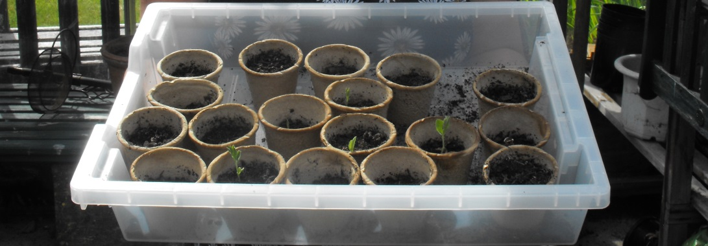
Tracey asked if the children would like to do some arts and crafts “yes please” they all said. We followed her to another room where she keeps all her pens and craft items.
When we went in Tracey showed us a `Treasure Box` that the residents had been filling up with items such as a Ration Book, skipping rope, and other items that the residents said are special to them.
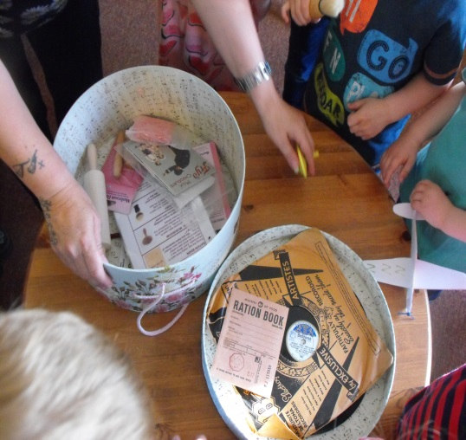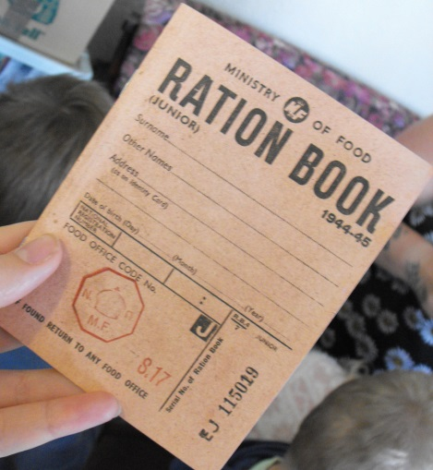
We then all went back to the first room and made some lovely planes, felt love hearts, felt footballs and other crafts.
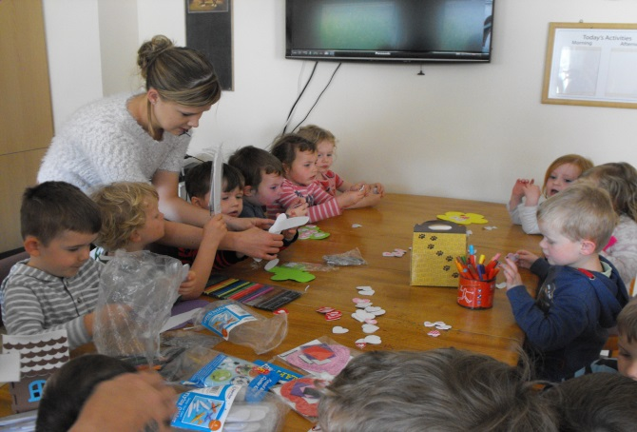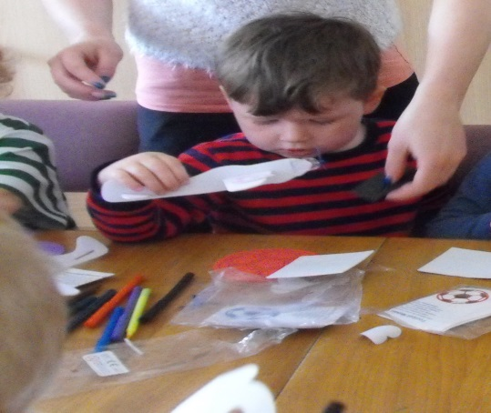
Some of us that had made planes took them into the garden to fly and one flew into a closed off area, Julie had to fish it out with a fishing net we thought this was funny.
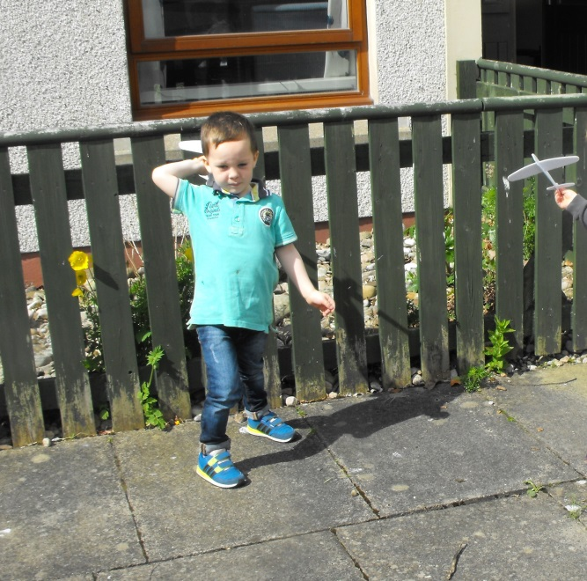
We then went into the dining room and Tracey showed us a game that she liked to play with the residents, she blew up a balloon and the residents had to hit it with a fly swat, we were allowed to try - it was really fun.
We then had snack, their cook asked if we were allowed to have homemade pancakes with jam on them mmmmm they were delicious we also had biscuits. Some of the residents came to sit with us and shared this lovely snack with us.
After we finished snack Lauren sat with us and we sang some songs with the ladies at Seaforth House, the residents like to hear us sing to them.
After we finished we gave Tracey our card and chocolates and said a really big thank you for having us. Tracey asked if we would like to hand the chocolates around to the residents and staff. Nicole helped us as we took them around to make sure that everyone got one.
Before we knew it, it was time to go back to Golspie ELCC as it was getting near to the time when we go home, but just before we went home we were all given a certificate to say WELL DONE on how well we had walked to and from Seaforth House.
WE WOULD LIKE TO SAY A BIG THANK YOU TO ALL THE RESIDENTS AND STAFF AT SEAFORTH HOUSE FOR HAVING US TO VISIT AND FOR COMING DOWN TO VISIT US
LOVE FROM ALL THE GIRLS, BOYS AND STAFF AT GOLSPIE ELCC.

