GOLSPIE ELCC
END OF YEAR TRIP TO
DUNROBIN CASTLE

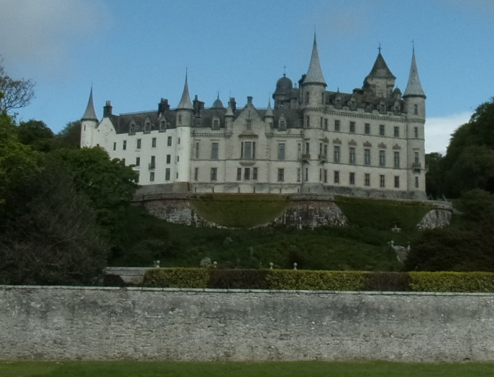
The boys and girls at Golspie ELCC along with their parents went for a walk to Dunrobin Castle to watch the falconry display and to look around the garden as their end of year trip.
The day before we went we were all asked what we would like in our sandwich as we were going to have a picnic there.
Here are our sandwiches, mmmm they look good we had some nice drinks as well.
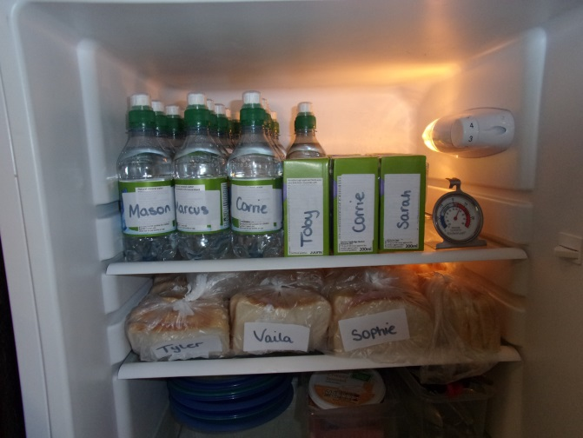
The morning of our trip arrived and we were all really excited, we all had a Hi-Viz jacket to wear and we held our parents hand as we walked along the coastline to get to the Castle.
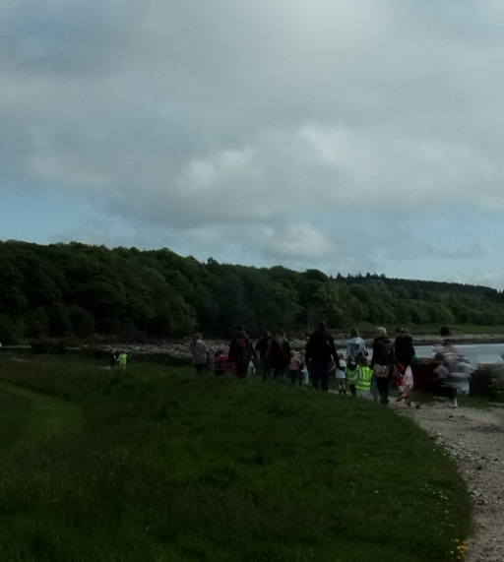
When we arrived at the castle we could see the birds that do the Falconry display some of them were really big, here are some of the birds that we saw.
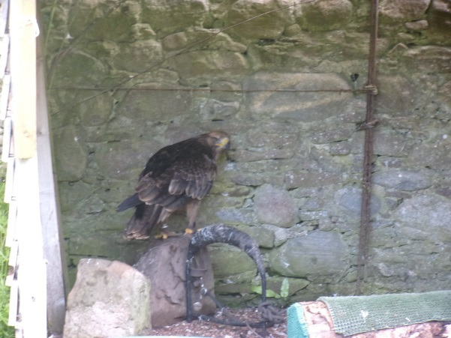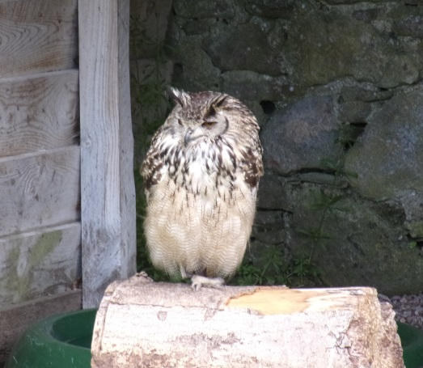
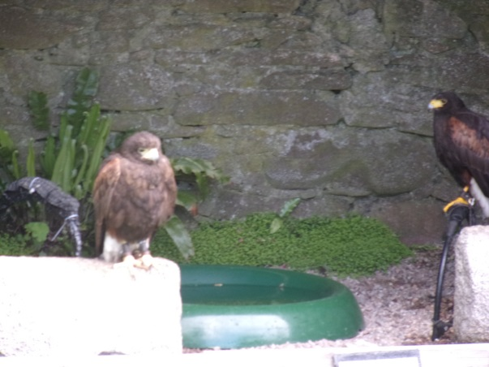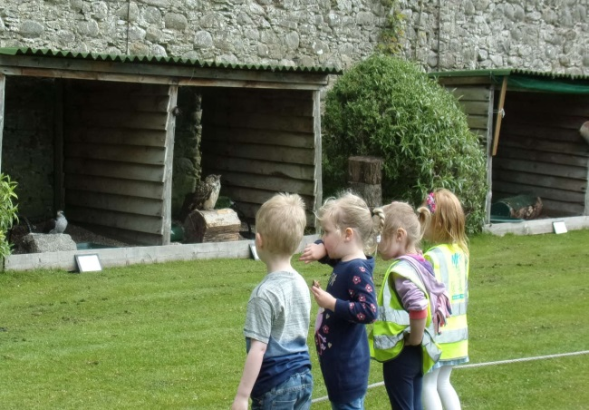
After we looked at the birds we went for a walk around the gardens and saw this lovely fountain (some of us called it a waterfall) that made us all wet from the spray - we thought this was funny.
The fountain was inside a little maze and we had to work out how to get to it, this was fun.
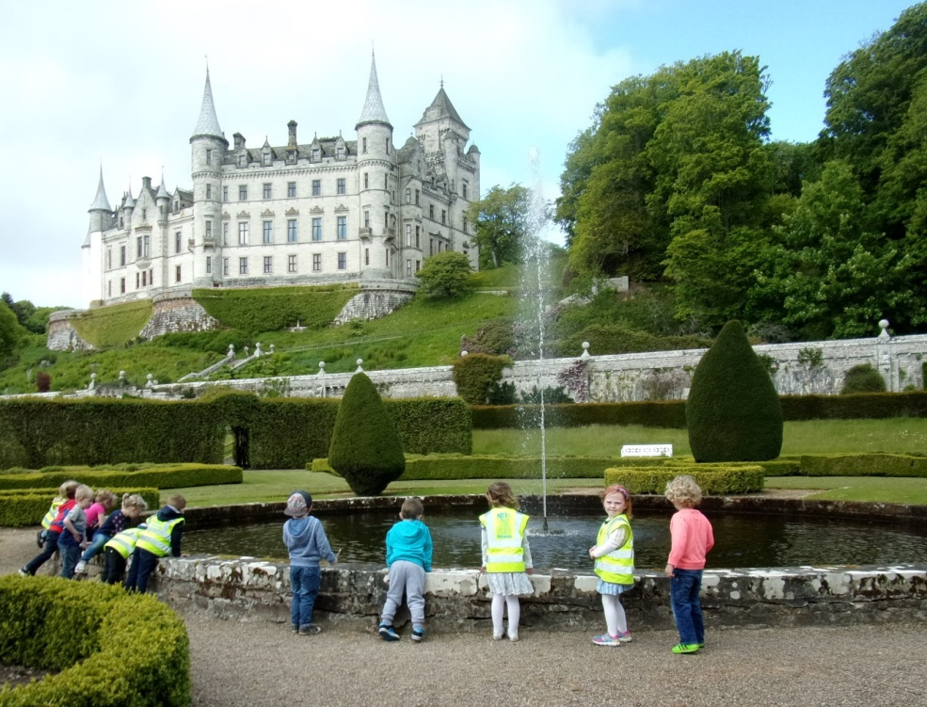
Some of us said how big and lovely the castle looked from here.
Soon it was time to watch the Falconry display so we all went to sit on the benches to wait to see which of the birds would be flying.
We were lucky to see an Eagle and an owl which some of us thought was going to land on our heads as it flew really low. The man telling us about the birds said that they eat rabbits and chicken nuggets, which we laughed at.
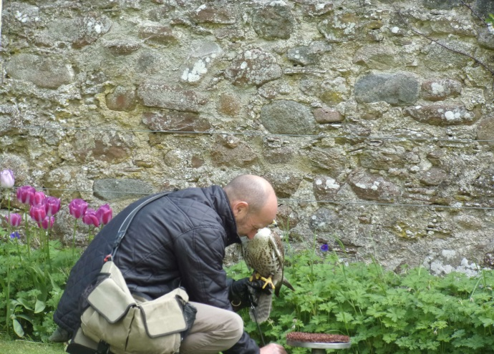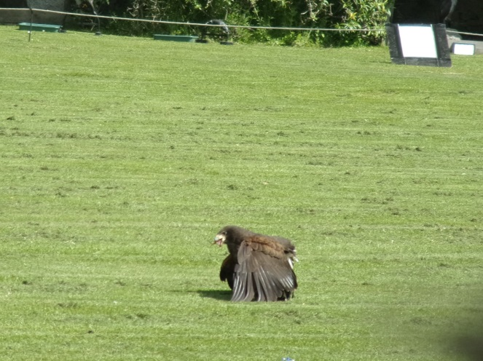

The man said that the owl has orange eyes and that it is not true that they only come out at nght as we can see here from this photo.
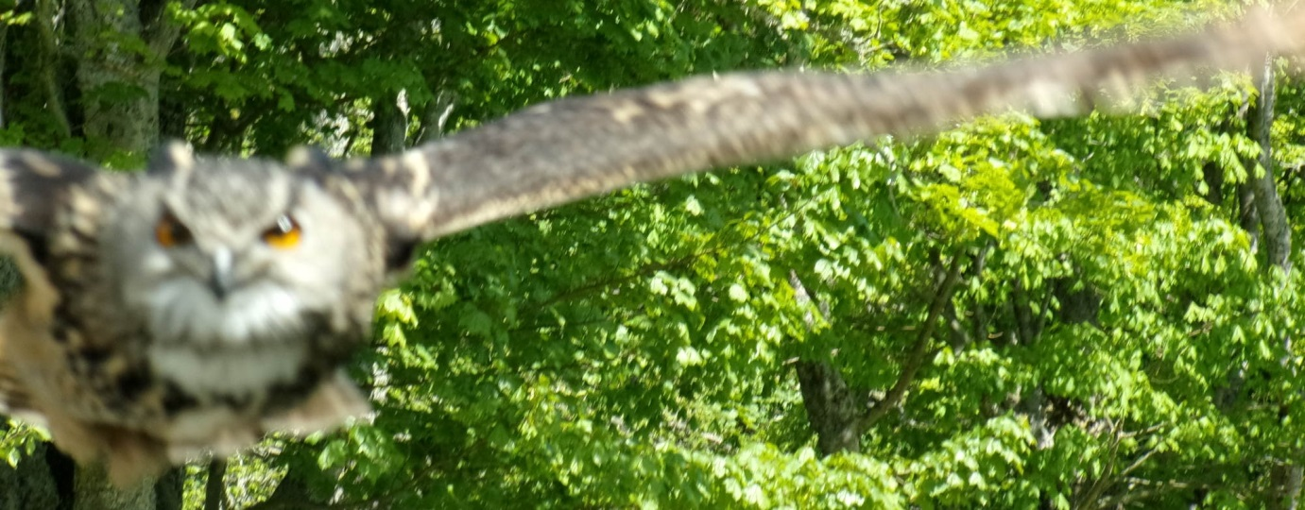
After the display we went and had our picnic in the garden.
After we had finished some of us pretended that Nicole was a train – Choo Choo all aboard.
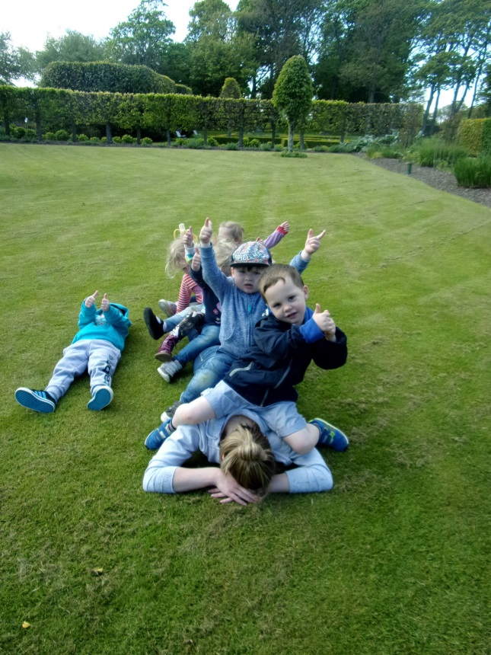
After we had all finished lunch we went and had a look around the museum which had lots of stuffed animals inside like a giraffe`s neck and head, an elephant, a crocodile and lots of different birds.
It even had a cabinet full of different birds eggs, some were the same eggs that the birds in the display would have hatched out off, some of these were really big and some were really small.
When we went inside the man who looks after the museum said that we were not allowed to take any photo’s, but we were allowed to touch some of the exhibits. There was so much to look at and it even had an upstairs. This was really good and some of our mummies and daddies said they had not even been in the museum before.
On our walk back to Golspie ELCC we stopped to play on the beach. We made some lovely sandcastles and some of us even turned into mermaids by covering our legs in sand.
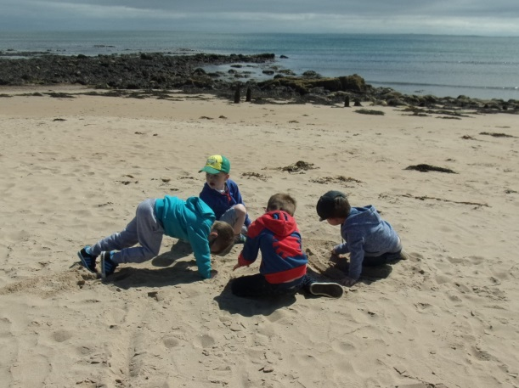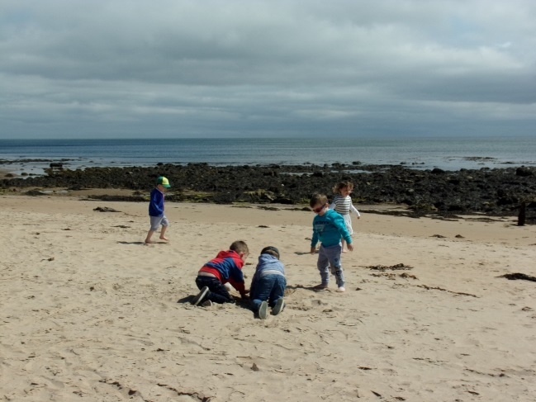
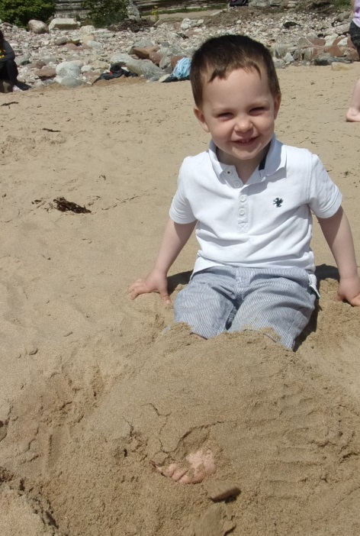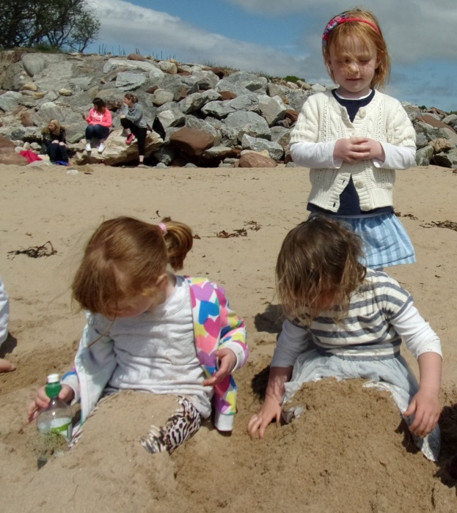

Here are some of the things we said we had enjoyed about our end of year trip to Dunrobin Castle.

I went to museum I liked the beach
I liked the waterfall (the fountain) The beach and the waterfall
My mummy and daddy went Seeing the birds
I liked the museum, the maze and the beach I enjoyed everything
Having picnic and seeing the birds In the garden, my sandwich and juice

