Summer Holidays Activities 2016
Themed activity weeks
Week beginning 4th July
Great Brora Bake Off
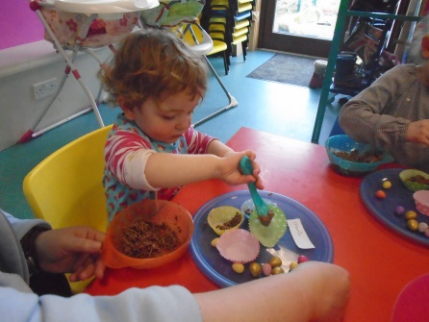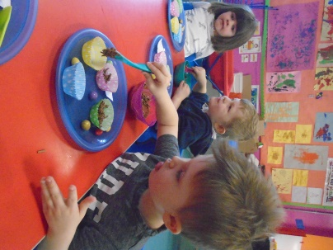
Week beginning 11th July
Monster Crafts
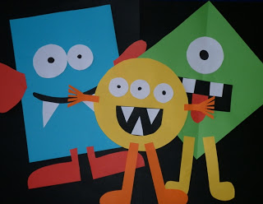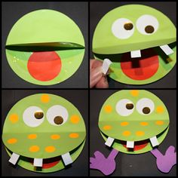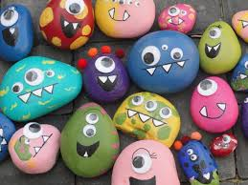

Week beginning 18th July
Pirates & Princesses
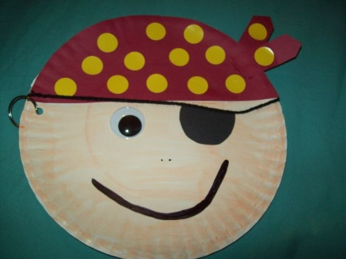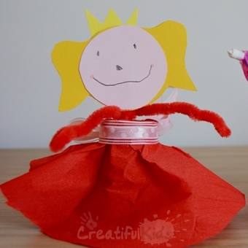

Week beginning 8th August
Science week
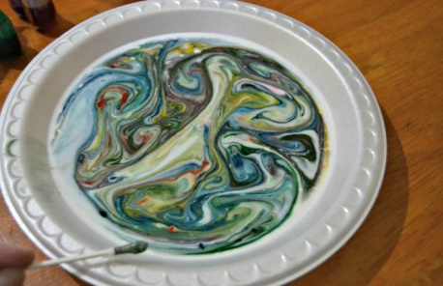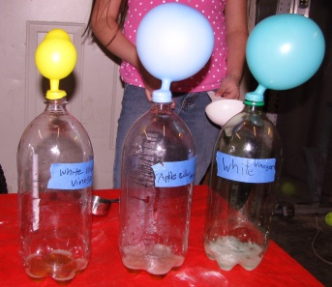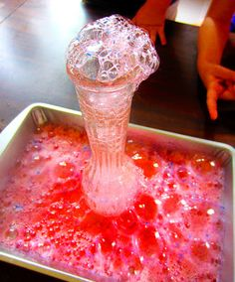

Arts & Crafts, Xbox, Wii, Flip camera, Dressing up, Construction toys, outdoor play, sports equipment and games, den building, baking
Just a small sample of the many activities taking place each day over the Summer holidays. To book please fill in the attached booking form. Book early as places are limited.

